Unit 4: Memory

4.1 Memory and its types
The purpose of memory devices is to store data either temporarily or permanently while the computer works with them. Computer memory is any physical device capable of storing information temporarily, like RAM (random access memory), or permanently, like ROM (read-only memory). Memory devices utilize integrated circuits and are used by operating systems, software, and hardware. The different types of memory are:
- cache memory
- primary memory
- secondary memory

4.1.1 Cache memory
Cache memory is an extremely fast small memory. It is between CPU and Main memory whose access time is closer to the processing speed of CPU. It acts as a high speed buffer memory between CPU and main memory and is used to store very active data and instructions temporarily during processing.
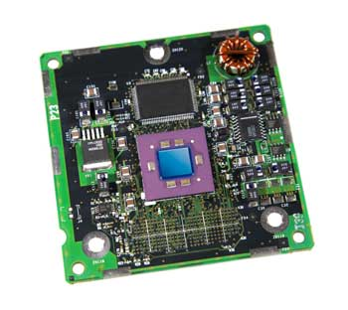
Figure: cache memory
Advantages
The advantages of cache memory are as follows −
- Cache memory is faster than main memory.
- It consumes less access time as compared to main memory.
- It stores the program that can be executed within a short period of time.
- It stores data for temporary use.
Disadvantages
The disadvantages of cache memory are as follows −
- Cache memory has limited capacity.
- It is very expensive.

4.1.2 Primary Memory (RAM, ROM, Virtual)
- The primary memory is also called the main memory or internal memory of the computer.
- It is one or more sets of chips that store the data and program instructions, either temporarily or permanently.
- It store data and program instruction during the processing.
- CPU can quickly read/write data and program instructions from the memory devices.
- The memory devices are fixed on the motherboard inside the computer case.
The different types of primary memory are:
- RAM
- ROM
- Virtual
Random access memory (RAM)
- RAM is temporary or volatile memory.
- That means the RAM losses its data when the computer is switched off or if there is power failure.
- RAM need a constant supply of power to hold its data.
- So we need to save the data files into the storage devices frequently, to avoid losing data in a power failure.
- From RAM we can read and write data into it so it also called read/ write memory.
- Program and data are stored in RAM during processing, so it is called the working memory of the computer.
- RAM is made up of a set of chips mounted on small circuit board.
- RAM is fixed on the motherboard in the memory card slot.
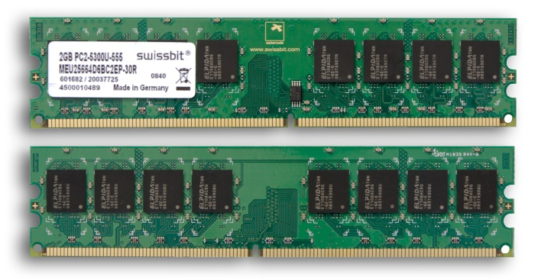
Figure: RAM
Some types of RAM are SRAM and DRAM:
Difference between SRAM and DRAM
SRAM | DRAM
It is made up of transistors | Memory cells are made up of small tiny capacitors
It is less dense | It is dense in nature
Charge doesn’t leaks from transistors | Charge leaks from capacitor
It doesn’t need periodic refreshing to preserve the information. | It need periodic refreshing to preserve the information
It is much faster than DRAM | It is slower than SRAM
It is more expensive than DRAM | It is cheaper than SRAM

Read only memory (ROM)
- ROM is permanent memory of the computer.
- It permanently stores the data even when the computer is switch off.
It is also called Non-volatile memory because it never loses its data.
- It is read only memory so that we can read data from the ROM but cannot write data into it.
- It store the instruction that the computer needs to operate.
- When computer’s power is turned on, it checks ROM for directions that help it start up and for information about its hardware devices.
- The instruction in the ROM are stored at the time of manufacture of the computer.
- ROM is fixed on the motherboard inside the computer case.
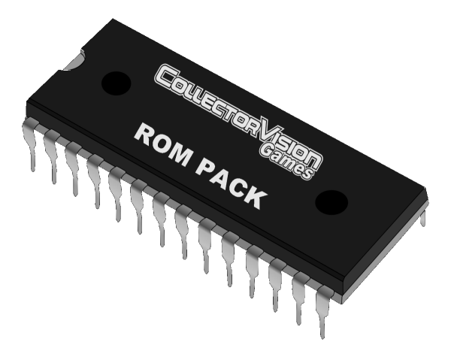
Figure: ROM
The various types of ROM are PROM, EPROM and EEPROM:
PROM
- It stands for Programmable Read only memory.
- It is a memory chip on which data can be written only once.
- Once a program has been written onto a PROM, it remains there forever.
- PROMs retain their contents when the computer is turn off.
- The difference between PROM and ROM is that a PROM is manufactured as blank memory, whereas a ROM is programmed during the manufacturing process.
- To write data onto PROM chip we need a special device called a PROM programmer or PROM burner.
- The process of programming a PROM is called burning the PROM
EPROM
- It stands for Erasable programmable read only memory
- It is a special type of PROM that can be erased by exposing it to ultraviolet light.
- Once it is erased it can be reprogrammed. The ultraviolet light clears its contents, making it possible to reprogram the memory.
- To write and erase an EPROM we need special device called a PROM programmer or PROM burner.
- EPROM differs from a PROM is that PROM can be written to only once and cannot be erased.
EEPROM
- EEPROM stands for electrically erasable programmable read only memory.
- It is a special type of PROM that can be erased by exposing it to an electrical charge.
- Like other type of ROM it retains its contents even when the power is turned off.
- Also like other types of ROM, EEPROM is not as fast as RAM.
Difference between RAM and ROM
RAM | ROM
It is a volatile or temporary memory | It is nonvolatile or permanent memory
It is read/ write memory | It is read only memory
It is fixed in the memory card slot on the motherboard | It is attached with the motherboard
It is working memory of computer | It is startup memory of the computer which stores the startup information
Virtual memory:
Virtual memory is a feature of an operating system that enables a computer to be able to compensate shortages of physical memory by transferring pages of data from random access memory (RAM) to disk storage (secondary memory). This process is done temporarily and is designed to work as a combination of RAM and space on the hard disk. This means that when RAM runs low, virtual memory can move data from it to a space called a paging file. This process allows for RAM to be freed up so that a computer can complete the task. Occasionally a user might be shown a message that says the virtual memory is running low, this means that either more RAM needs to be added, or the size of the paging file needs to be increased.

4.1.3 Secondary memory
- Secondary storage devices are used to store data and program instructions permanently for the future use.
- The data storage capacity of storage device is very high than memory device.
- It storage capacity is from Gigabytes to terabytes for personal computer.
- The application software and system software are stored on the storage devices.
- Examples of storage devices are: floppy disk, zip disk, hard disk, magnetic tape, CDs etc.
The storage devices are broadly categorized into the following types. They are:
- Magnetic storage devices
- Optical storage devices
- Sequential storage device
- Memory storage devices
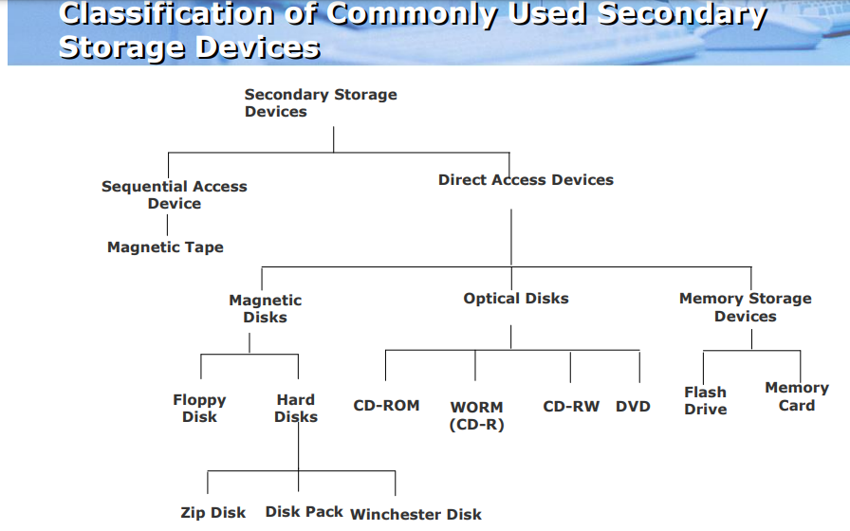
- Magnetic storage devices
- Computer systems need to store data in digital format.
- One of the most widely used types of digital data storage is magnetic storage.
- This refers to any type of data storage using a magnetized medium.
- The surface of these devices are coated with magnetic material such as iron oxide or ferrous oxide, which can be magnetized. That is which reacts to a magnetic field.
- The presence of a magnetic field represents a 1 bit and absence represents a 0 bits.
- E.g. floppy disks, Super disks, hard disks, pen drives etc.
- Optical storage devices
- The disc that uses laser light technology to store and retrieve data is called optical storage disc.
- An optical storage media is flat, round, portable metal disc, which is coated with a thin metal or plastic or other material that is highly reflective.
- The information on the optical disk is stored in the form of pits and lands.
- A land reflects the laser light, which is read as binary digit 1.
- A pit absorbs or scatters light, which is read as binary digit 0.
- The high powered laser beam creates the pits.
- A lower powered laser light reads data from the disc.
- The most commonly used optical storage discs are CD, DVD, Blu-ray disk, etc.
- Sequential storage device
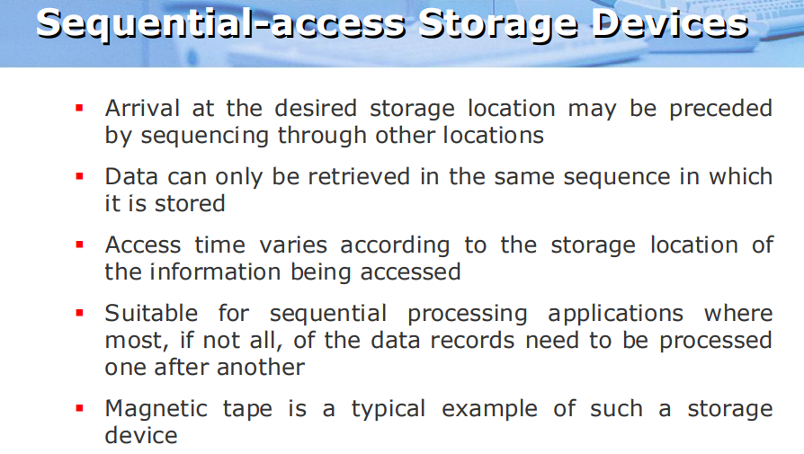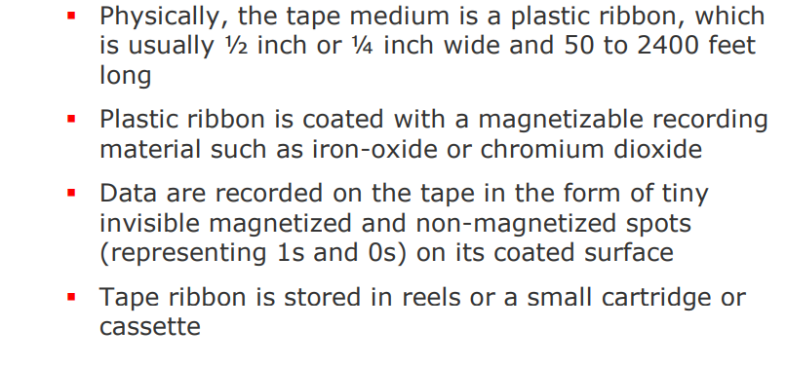

4.2 Memory hierarchy
The memory organization of the system can be done by memory hierarchy. It has several levels of memory with different performance rates. But all these can supply an exact purpose, such that the access time can be reduced. The five hierarchies in the memory are registers, cache, main memory, magnetic discs, and magnetic tapes. The first three hierarchies are volatile memories which mean when there is no power, and then automatically they lose their stored data. Whereas the last two hierarchies are not volatile which means they store the data permanently.
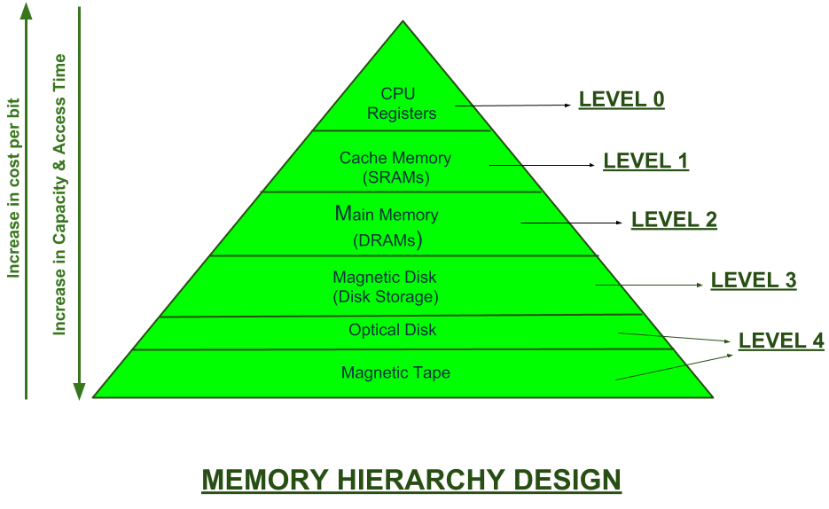

We can infer the following characteristics of Memory Hierarchy Design from above figure:
- Capacity:
It is the global volume of information the memory can store. As we move from top to bottom in the Hierarchy, the capacity increases.
- Access Time:
It is the time interval between the read/write request and the availability of the data. As we move from top to bottom in the Hierarchy, the access time increases.
- Cost per bit:
As we move from bottom to top in the Hierarchy, the cost per bit increases i.e. Internal Memory is costlier than External Memory.

4.3 Characteristics of Memory System
The key characteristics of memory devices or memory system are as follows:
- Location
- Capacity
- Unit of Transfer
- Access Method
- Performance
- Physical type
- Physical characteristics
- Organization
1. Location: This shows whether the location of the memory device is external or internal to the computer. Internal memory and external memory are a lot different from each other. While the internal memory is embedded directly on the computer motherboard, external memory is separate from the main computer unit, in the form of a storage disk such as disks and tapes. External memory devices are controlled from the I/O controllers, while internal memory takes the form of cache memory, registers and main memory. The three possible location are CPU, external (secondary) and internal (main memory/primary memory).
2. Capacity: Capacity is a measure of amount of data the memory device can store. For internal memory, this is measured in terms of bytes, while in external memory, it is measured in bytes or words, where a word length may be 8, 16 or 32 bits.
3. Access Method: Access method refers to the methods through which data is written to, and consequently read from a memory device. There are four access methods which are as listed below;
- Direct Access Method
- Sequential Access Method
- Random Access Method
- Associative Access Method
Direct Access Method: Every memory block is marked by a unique address. Access is made directly by first reaching to the vicinity and the following sequential search. An example of a memory device that uses the direct access method is the hard disk.
Sequential Access Method: Uses a shared read-write mechanism to sequentially access data. An example of a storage device that uses the sequential access method is the tape.
Random Access Method: Each block in memory has its unique and physically wired-in addressing mechanism. An example of a storage device that uses the random access method is the RAM.
Associative Access Method: Access to data is made by comparing the required bit location within a word based on a specified data element. An example of a storage device that uses the associative access method is the cache memory.
4. Unit of Transfer: This is a measure of the transfer rate of the data in and out of memory. In internal memory, this is determined by the number of electrical lines going into and coming out of the memory with each line carrying data of word length. In external memory, this is determined by the number of bits read out or written into the memory at a time.
5. Performance: This a measure of overall efficiency of the memory system. There are three (3) parameters used to measure performance.
- Transfer Rate
- Memory Cycle Time
- Access Time
Transfer Rate: This is the rate at which data is transmitted into and out of memory.
Memory Cycle Time: The time required to access a block in memory as well as the period to the start of the second access.
Access Time: The time required to carry-out read or write operation.
6. Physical Type: This is the shape and form the memory takes. There are about four (4) of such forms which are as listed below:
- Magnetic
- Semiconductor
- Optical
- Magneto-optical
7. Organization: The organization of a memory system generally refers to the physical arrangement of the bits.
8. Physical Characteristics: This is the nature of the memory system. This can take the forms listed below;
- Volatile
- Non-volatile
- Erasable
- Non-erasable

4.4 memory measurement unit
Computer system consists of data storage unit. A computer has main storage and secondary storage. A large amount of data can be stored in secondary storage like hard disk, pen drive, CD/DVD, etc. for future use. The main memory (RAM) stores currently used data. Computer stores data in term of 0 and 1. The different units of memory measurement in computer are given below:
s.no | Memory unit | Description
1 | Bit | 1 Bit = 0 or 1
2 | Nibble | 1 Nibble = 4 Bits
3 | Byte | 1 Byte = 8 Bits
4 | Kilobyte(KB) | 1 Kilobyte (KB) = 1024 Bytes
5 | Megabyte(MB) | 1 Megabyte (MB) = 1024 KB
6 | Gigabyte(GB) | 1 Gigabyte (GB) = 1024 MB
7 | Terabyte(TB) | 1 Terabyte (TB)= 1024 GB
8 | Petabyte(PB) | 1 Petabyte (PB) = 1024 TB
9 | Exabyte(EB) | 1 Exabyte (EB) = 1024 PB

4.5 Memory Addresses
A memory address is an exact assigned location in RAM used to track where information is stored. On a single computer memory IC, there can be 1 million, 2 million or more memory addresses that can be accessed at randomly, which is why memory is called RAM. This binary address is defined by an ordered and finite sequence allowing the CPU to track the location of each memory byte. Modern computers are addressed by bytes which are assigned to memory addresses – binary numbers assigned to a random access memory (RAM) cell that holds up to one byte. Data greater than one byte is consecutively segmented into multiple bytes with a series of corresponding addresses. Hardware devices and CPUs track stored data by accessing memory addresses via data buses. Before CPU processing, data and programs must be stored in unique memory address locations
For example, your computer might have 16 or 32 or 64 megabytes of RAM installed right now. RAM holds the programs that your computer is currently running along with the data they are currently manipulating. Memory can be thought of simply as an array of bytes. In this array, every memory location has its own address - the address of the first byte is 0, followed by 1, 2, 3, and so on. Memory addresses act just like the indexes of a normal array. The computer can access any address in memory at any time. It can also group bytes together as it needs to form larger variables, arrays, and structures.

4.6 Error correcting codes
Error correction code (ECC) checks read or transmitted data for errors and corrects them as soon as they are found. ECC is similar to parity checking except that it corrects errors immediately upon detection. ECC is becoming more common in the field of data storage and network transmission hardware, especially with the increase of data rates and corresponding errors.
Error correction code is applied to data storage via the following steps:
- When a data byte or word is stored in RAM or peripheral storage, a code-specifying bit sequence is estimated and stored.
- When the byte or word is called for reading, a code for the retrieved word is calculated according to the original algorithm.
- If the codes match, the data is error free and is forwarded for processing.
- If the codes do not match, the changed bits are caught through a mathematical algorithm and the bits are immediately corrected.
Data is not verified during its storage period, but is tested for errors when it is requested. If required, the error correction phase follows detection. Frequent recurring errors at the same storage address indicate a permanent hardware error. In this case, the system sends the user a message, which is logged to record the error location(s).

4.7 Memory package and types
Memory package is a small circuit board that contains memory chips. SIMM, DIMM, SODIMM, AND RIMM are some of the memory packages. These packages are the form factors of RAM chip. The installation of a memory depends on the form factors of a RAM. A form factor is the size and shape of the memory packages.
The different types of memory package are:
- SIMM (Single In-line Memory Module)
- DIMM (Dual In-line Memory Module)
- SODIMM (Small Out-line Dual Inline Memory Module)
- RIMM (Rambus In-line Memory Module)
- Micro DIMM (Micro Dual In-line Memory Module)
Single In-line Memory Module (SIMM):-
SIMM is a small circuit board designed to hold memory chips. It contains pins for accepting data from the control circuit. These circuit boards or modules are known as packages. There are various SIMM packages available based on the number of pins it contains. For Example there are 30 pin packages and 72 pin packages.
The capacities of a 30-pin package SIMM package are 256 Kb, 1 MB, 2 MB, 4MB, 8MB, 16MB RAM. It contains 2, 4, or 8 chips per module. A 30-pin SIMM package has a data bus width of 9 bits with 9- bit parity. Parity checks the accuracy of the data transmission. An odd parity and an even parity are the two modes of parity checking.
A 72-pin SIMM package has 32-bit data width with 36-bit parity. PS/2 is another term used for the 72-pin package. The capacities of a 72- pin package are 1 MB, 2MB, 4MB, 8MB, 16MB, 32MB, 64MB AND 128MB RAM. It contains 2, 4, 8, or 16 data chips per module. FPM DRAM uses a 72-pin package.
Dual In-line Memory Module (DIMM):-
DIMM package is also a small circuit board that contains the memory chips. The difference between the SIMM and DIMM is that DIMM is a 168-pin package. The data of the DIMM packages are 64-bit, 72-bit, or 80-bit. A 168-pin DIMM package is available in the SDRAM, EDO or FPM DRAM chips.
Rambus Inline Memory Module (RIMM):-
RDRAM chip uses the RIMM memory package. This package is same as the DIMM package. It only differs in the pin configuration. The high bandwidth and the low latency application use this memory package. The RIMM package has a data storage speed of 600 MHz, 711 MHz, 800 MHz and 1066 MHz. It has 184 connecting pins. The distance between each pin in the RIMM package is 1mm. This package starts operating from 2.5 voltage supply. The RIMM package are available in 16-bit data buses 32-bit data buses, and 64-bit data buses. The memory bandwidth of the RIMM package is up to 9.6 GB per second.

4.8 Magnetic disk
Magnetic disk is a direct access secondary storage device. It is a thin plastic or metallic circular plate coated with magnetic oxide and encased in a protective cover. Data is stored on magnetic disks as magnetized spots. The presence of a magnetic spot represents the bit 1 and its absence represents the bit 0. It uses a magnetization process to write, rewrite and access data. It is covered with a magnetic coating and stores data in the form of tracks, spots and sectors. Hard disks, zip disks and floppy disks are common examples of magnetic disks.

The working of magnetic disk
- The surface of disk is divided into concentric circles known as tracks. The outermost track is numbered 0 and the innermost track is the last track. Tracks are further divided into sectors. A sector is a pie slice that cuts across all tracks. The data on disk is stored in sector. Sector is the smallest unit that can be read or written on a disk. A disk has eight or more sectors per track
- Magnetic disk is inserted into a magnetic disk drive for access. The drive consists of a read/write head that is attached to a disk arm, which moves the head. The disk arm can move inward and outward on the disk.
- During reading or writing to disk, the motor of disk drive moves the disk at high speed (60–150 times/sec.)

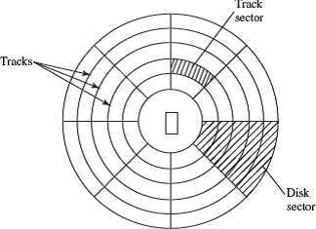

FIG: surface of magnetic disk.
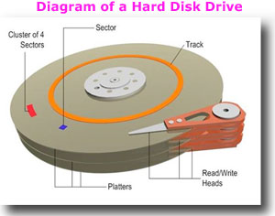
FIG: diagram of hard disk
Track and sector: Tracks are concentric circles that are broken up into storage units called "sectors," typically 4,096 bytes long. The sector is the smallest unit that can be read or written. Tracks are only 75 nanometers wide today, and bit density is greater than one terabit per square inch.
Cluster:
A cluster, in the context of a hard disk, is a group of sectors within a disk and is the grouping by which disk files are organized. A cluster is larger than a sector, and most files fill many clusters of disk space. The hard drive is able to find all the clusters on a disk because each cluster possesses its own ID.

4.9 DVD RW
The DVD-RW drive in a computer is a common type of optical drive that can read and write information from and to a DVD-RW disc. The disc rotates rapidly when inserted into the drive, and a laser beam reads the information from the disc. The "DVD" part of the term DVD-RW means "digital versatile disc." DVDs ordinarily hold around 4.7GB of data, in contrast to CDs (compact discs) that hold around 700MB. DVDs are often used to store video files, but they can be used to hold any type of information. As you may expect, you need a DVD drive to read information from a DVD, but DVD drives can also read information from CDs.The differences between DVD-ROM, DVD-R and DVD-RW drives and discs are revealed by the suffix that follows the DVD.
DVD-RW
RW stands for "rewritable." These discs can be written onto multiple times, erasing the original information in the same way you might replace information on a hard drive. You can erase and rewrite the information up to 1,000 times. A DVD-RW drive can write onto DVD-RW discs and often onto DVD-R discs as well. Using phase change technology, the first DVD+RW discs held 3GB per side, but were later increased to the industry standard 4.7GB. A double sided disc holds 9.4GB
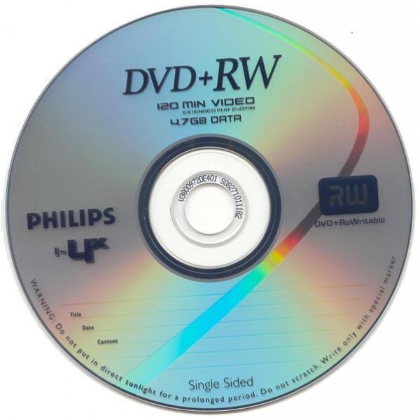

DVD-ROM
ROM stands for "read-only memory," so DVD-ROM discs can't have any additional information burned onto them, and a DVD-ROM drive can't write information onto any type of disc.
DVD-R
R stands for "recordable," so DVD-R discs can have information recorded on them, but they can only have this done once. A DVD-R drive can only record onto DVD-R discs (not DVD-RW ones), and these aren't common.

4.10 Flash Drive
A flash drive is a small and portable storage device that connects to computers and other devices using a USB Type-A plug that is built onto the drive. The way flash drives work is similar to solid-state drives, or SSDs, and some people refer to them as SSDs. However, SSDs are typically not portable. Flash drives differ from hard disk drives and optical drives because they do not have any moving parts. The lack of moving parts prevents some of the errors that might occur in a hard disk drive if it was carried from location to location.
Flash drives are very simple to use. They are plugged into the USB port of the host device, which causes an alert to show on the screen that a flash drive is in place. This alert allows you to access the content of the drive and open the files as needed. You can save some or all of the files on the flash drive onto the host system to be used there. Many people use flash drives to transfer data from one system to another in this way.
Most flash drives have a storage capacity from 8 GB to 64 GB. Smaller and larger flash drives are also available, but they're harder to find. One of the first flash drives was just 8 MB in size. The largest one we're aware of is a USB 3.0 flash drive with a 2 TB (2048 GB) capacity from Kingston.

FIG: FLASH DRIVE